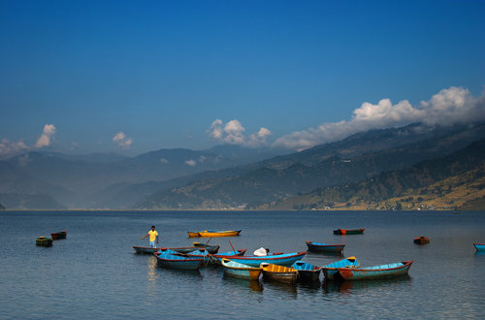 | 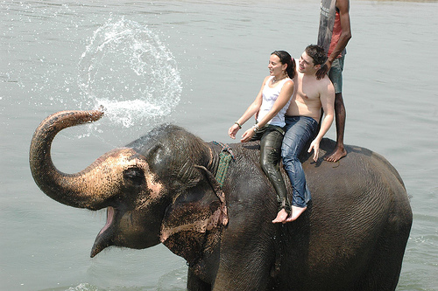
Itinerary:
Day 01: Arrival at Kathmandu airport
You will be met by our representative and transfer to hotel. After refreshment in hotel, short briefing about the programs.
KATHMANDU DURBAR SQUARE: Durbar Square, one of the old capitals of the Kathmandu valley, is a synthesis of Hindu and Buddhist temples, stupas and statues, and is often the site of festivals, marriages and other ceremonies.
Day 02: Kathmandu city sightseeing (1315m)
Today we explore the Kathmandu valley.
SWOYAMBBHUNATH: Climb the many steps to Swayambhunath (the monkey temple) with its commanding views of Kathmandu, its whitewashed stupas and its unique synthesis of Buddhism and Hinduism. This temple was found about 2000 years ago it is said that
Kathmandu was filled with water. Manjusri drained the water by his sword. Swayambhunath temple is also known as the self created Stupa.
Pashupatinath is one of the most significant Hindu temple of Lord Shiva in the world. It is Located on the banks of bagmati river which is also known as holly river. The Pashupatinath Temple is listed in the world heritage site by UNESCO. Lord Shiva is known my many names And out of that Pasupati is also the one.
BOUDHANATH: The striking Buddha eyes of Boudhanath Stupa watch over a lively and colorful Tibetan community and attract pilgrims from all over the Himalayan Buddhist realm. In the midst of traditional gompas, and hung with long strings of multi-colored prayer flags, Boudhanath attracts Sherpas, Tibetans and tourists alike for daily circumambulations (koras) of the stupa.
Day 03: Kathmandu - Chitwan National Park.
After breakfast drive to Chitwan National Park by private car (185km/5 ½ hours). Enroute we'll visit Manakamana Temple and then have lunch. Upon arrival in Chitwan, you will check into the hotel and have a welcome drink and briefing about jungle activities. In the evening you can enjoy the Tharu stick dance and dinner. Overnight stay at the resort.
Day 04: Chitwan National Park.
Wake up call with tea/coffee followed by a nature walk and bird watching tour. Have breakfast and start your jungle safari on elephant. Visit the elephant breeding centre. In the afternoon take a canoe ride or jungle hike. The Tharu stick dance will be followed by dinner. Overnight stay at the resort.
Day 05: Chitwan – Lumbini.
Morning depart for Lumbini and on arrival check in at hotel. Afternoon visit Lumbini, the birthplace of Buddha who was born around 2500 years ago. The Rummindei Pillar, raised in 249 BC, marks this sacred spot. Also unearthed are four gateways, difense wallsand a wealth of coins and artifacts. Beside the Ashokan Pillar and the Maya Devi Temple, plinths of huge temples and a pond, where the infant and his mother bathed, have been unearthed. Overnight at the hotel.
Day 06: Lumbini – Pokhara:
Early morning after breakfast drive to Pokhara by private Car. Upon arrival, check into the hotel. Your afternoon is free for personal activities and a 1-hour boat ride on Fewa Lake. Dinner and overnight stay at hotel.
Day 07: Pokhara Tour:
Pokhara is a natural capital of Nepal and a starting point of trekking in Annapurna. Pokhara exploration includes drive or hike to several view points for different perspectives of geographical enigmas. One can hike and mountain bike to several hillsides like Sarangkot, World Peace Stupa etc. The Tibetan Refugee Camp is another palce of interest in Pokhara. Your exploration sites will be designed according to your preferences.
Pokhara sightseeing Points: Sarangkot Sunrise View, Devi's Fall, Tibetan Refugee Camp, World Peace Stupa.
Day 08: Pokhara – Kathmandu:
Early morning after breakfast we'll visit Nepal Mountaineering Museum & later we will drop you at Domestic airport for flight back to Kathmandu. Transfer to Hotel.
Day 09: Kathmandu - Nagarkot:
After having breakfast we'll drive to Nagarkot. Nagarkot is situated 32 kilometers, 1.5 hrs drive east of Kathmandu at an altitude of 2,175 meters. The panoramic view of the major peaks can be seen from here. This place is also famous for viewing sunrise and sunset. Overnight at hotel
Day 10: Nagarkot – Kathmandu:
Early morning wake up call to see the magnificent sunrise over the Himalayas. Breakfast and transfer back to Kathamndu on the way we can visit Bhaktapur by private car. Transfer to Hotel.
Day 11: Departure:
Transfer to airport for final departure or continue your onwards trips. Tour ends with THANK YOU!

Hotels:
Kathmandu: Royal Penguin Boutique Hotel/ Aria Boutique Hotel & Spa
Pokhara: Temple tree resort
Chitwan: Green Park
Lumbini: Lumbini Crystal
Nagarkot: Fort Resort
In the aforementioned tours,
It is also possible to take 1 hr mountain flight to Everest.
SERVICES INCLUDED:
- Accommodation in twin sharing basis with breakfast
- All transfers by private Japanese Vehicle for the whole trip
- English speaking tour guide.
- 3 days / 2 nights package tour in Royal Chitwan National Park includes all meals, accommodation, jungle activities, park fees, tourist bus ticket KTM – Chitwan.
- Return flight Pokhara to Kathmandu + airport taxes
- Sightseeing entrance fees
- All Government taxes

SERVICES EXCLUDED:
- Lunch & dinner during stay in Kathmandu, Lumbini, Nagarkot & Pokhara
- All bar bills
- Travel insurance
- Any extra cost not mentioned in service includes
The rates depend on the number of travellers and the class of the hotel room. For your special price please contact us:

https://royalpenguinadventures.com/contact

email: royalpenguinadventures@gmail.com

phone: +977 1-4219956, 4215013, 4219957

